Farm/Owner Name: _______________________________________ Lot: ________ Concession: _________
Street Address: _________________________________ Town: ________________ Township: ___________
Postal Code: _____________ COUNTY: _______________ Farm Business Registration #: ______________
Type of Farm: _____________ Telephone: ___________________ Email: ____________________________
Title | Name | Relationship to Original | Years Owned
Present Owner(s) |  |  | to
Original Owner (s) |  |  | to
Second Owner (s) |  |  | to
Third Owner (s) |  |  | to
Fourth Owner (s) |  |  | to
Fifth Owner (s) |  |  | to
❒ I have attached copies of relevant land registry records OR
❒ I have the signature of my local JFAO Provincial Director as verification of these records.
Provincial Director Name: _____________________ Signature: ____________________ Date: ___________
To the best of my knowledge the above information accurately represents at least (circle one)
100, 125, 150, 175, 200, or 225
years of family ownership. I believe that the farm of which I am the current owner qualifies as a Century Farm in the province of Ontario; verifiable through the attached photocopied documentation or by my local Provincial Director who has signed above.
I acknowledge the information obtained will be used for historical purposes only.

Farm Owner Signature:  _____________________________ | Date:  __________

Item |  | Qty | Total
New 100 Year Sign | $100
Replacement 100 Year Sign | $75
125 Year Add On Sign | $50
150 Year Add On Sign | $50
175 Year Add On Sign | $50
200 Year Add On Sign | $50
225 Year Add On Sign | $50
Shipping Via Canada Post  (must include) | $25
 | TOTAL
❒ I have enclosed payment of $_____________ to the specifications of the above order form. Cheques payable to Junior Farmers’ Association of Ontario, e-transfer to finance@jfao.on.ca or credit card payment to be arranged via phone.
❒ I am aware it may take 4-8 weeks to process, the price is subject to change without notice and
that incomplete forms will be delayed and/or rejected.

Office Use  ONLY | Paid: | Chq #: |  Shipped OR  Delivered by
Office Use  ONLY | Received: |  | Verified by: Entered by:

The Ontario Century Farm Sign (CFS) was initiated as a Canadian Centennial project by the Junior Farmers’ Association of Ontario. Due to a great demand for the signs, JFAO proudly continues the program and has expanded it to recognize even greater milestones through add-on signs marking 125, 150, 175,200 & 225 years. The sign fee supports the cost of the program and leadership development within JFAO, aiding in the club’s mission “to build future rural leaders through self-help & community betterment.”
The regulations governing designation of an Ontario Century Farm are as follows:
- Direct descendants of the applicant’s family must have owned the farm for 100 or more consecutive years.
- A family member must still be living on the farm, and it must be in active operation within the family.
Note: Incorporated and/or farm properties divided amongst several descendants are eligible provided both of the above requirements are met.
Submit completed application and payment to JFAO. A copy of all relevant land registry records must be submitted with the application OR the application must be approved and signed by the JFAO Provincial Director for the area where the farm is located. Land registry records are available online. To inquire about your Provincial Director please contact JFAO either by telephone at 226-820-6137, by email at info@jfao.on.ca or online at http://www.jfao.on.ca/contact.
Please note that documentation will not be returned, therefore do not send original documents. Please send a complete application with required copies whether applying for new, replacement or add-on signs as JFAO may not have complete records of previous applications. The final decision regarding the eligibility of applications will be made by JFAO based on information provided by the applicant.
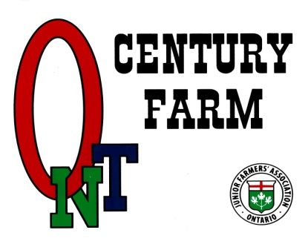 |  | 
 | 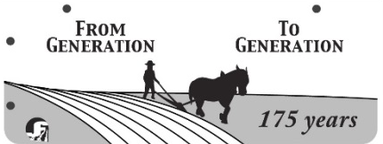 | 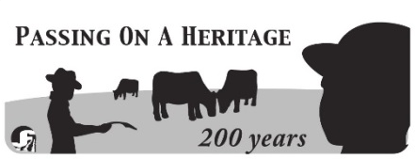

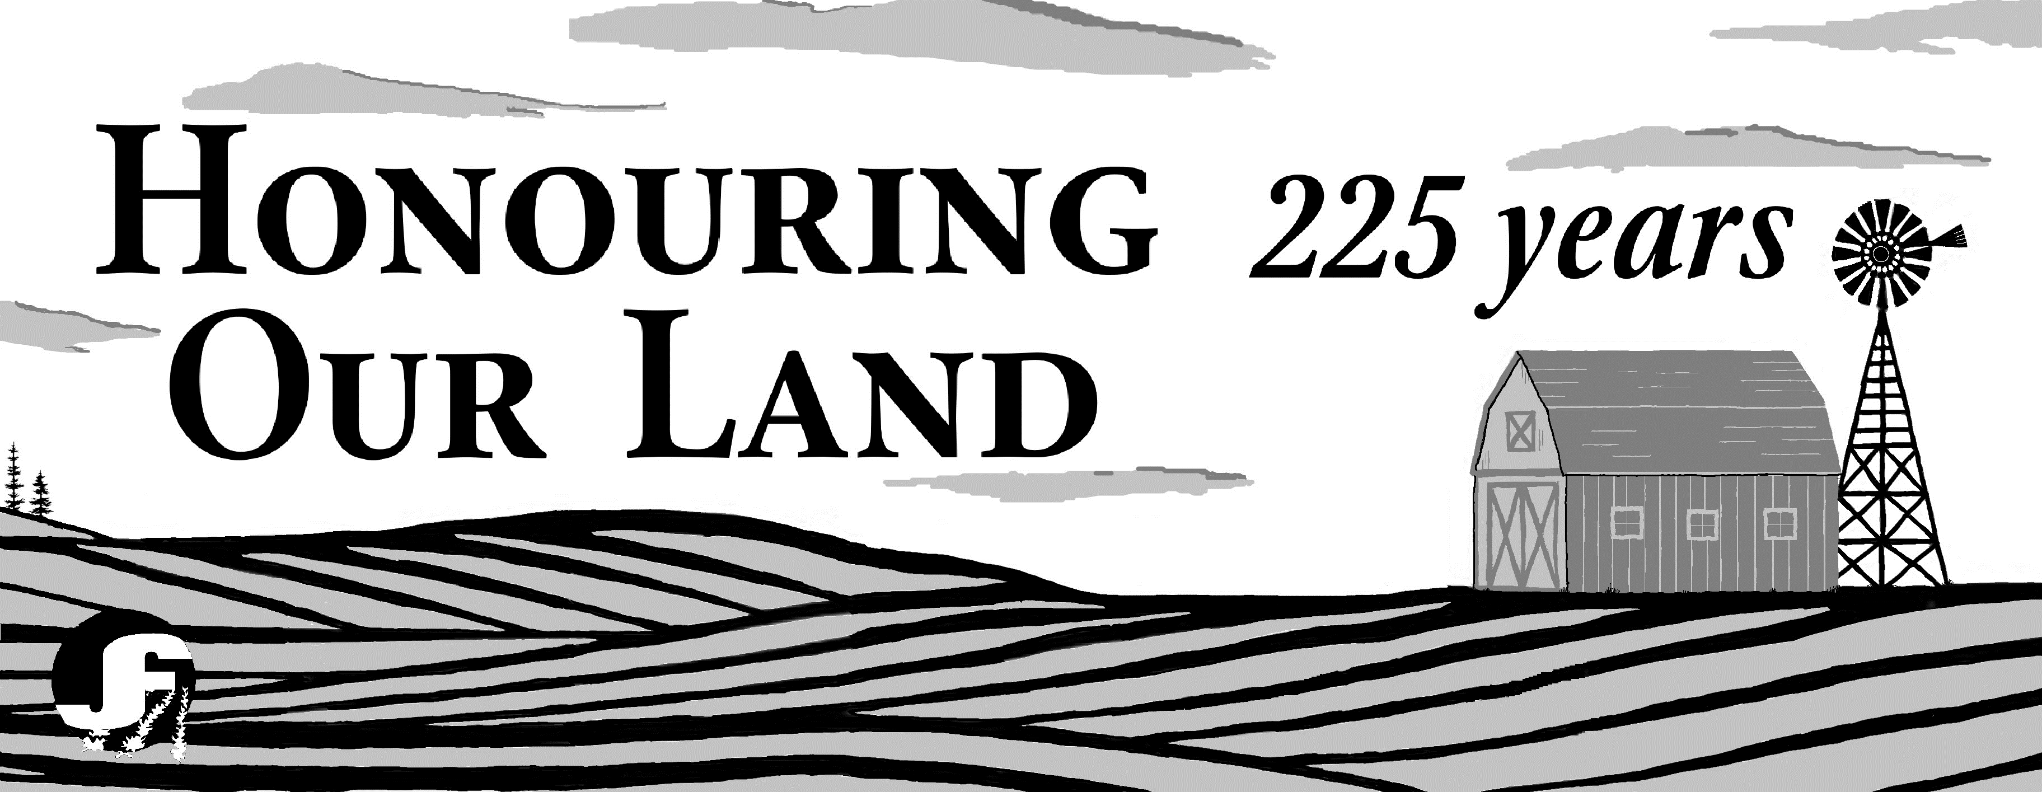
The 16” x 19” CFS is constructed of aluminum and is identically printed on both sides in colour. The new “add-on” signs are of an equal width and approximately 1/3 as high, offered in black and white. There are two holes along the top, side and bottom of each sign for hanging from an appropriate standard (not included). These signs should maintain their attractive condition for several years. Experience has shown that signs not adequately secured or over-exposed to road salt may deteriorate more rapidly. Applying tape over the painted design is NOT recommended. JFAO does NOT guarantee the life of any sign.

