Club Affiliation Report – President’s Guide
Filling out these reports in full leaves an important record of your club’s activity for future members while providing ideas for other clubs and helping JFAO to show off how much our members do. In order to be affiliated with JFAO and to maintain the right to use the name “Junior Farmers” or “JF Club,” each club must fulfill a minimum set of requirements each year. These requirements are outlined in the JFAO Constitution and further explained in the Policies, as approved by all clubs. Both of these documents are available online or from the JFAO office. It is the Club President’s responsibility to ensure that each of the requirements is fulfilled during the year. Incomplete/late affiliation requirements will result in the withdrawal of provincial benefits, including insurance, and the club will no longer be allowed to participate in provincial events, including voting at March Conference, until reports are complete and fine/late fee paid.

To be affiliated as a JF club, each club must:
- Complete the affiliation report booklet – due at the January Board meeting (by noon)
- Have its annual financial records reviewed and report submitted – postmarked by January 31
- Submit club election forms – postmarked by January 31

Hints for filling out the affiliation report booklet:
- Don’t stop at just reporting on the affiliation requirements. If your club does more, include it! The reports are your opportunity to brag! Show us why your club is great and your community should be proud to have a JF club – and include enough information so that someone who knows nothing at all about your club will understand what JF is about. A minimum of 5 labelled, family-friendly photos is required – labelled with full names and what is happening in each. A well-done report is a great marketing tool for displaying at events in the community!
- Use some creativity in your activities – along with your standard projects, try to find something new to do to keep members interested each year and generate more media interest. Your community betterment project should be something initiated or driven by your club, not just tagging along with something another group is doing. Try to have some kind of signature event or project that is unique to your club! The more details of the event, the better idea we get of how successful it was, and the more useful this info is to other clubs.
- Please read each section carefully and follow the format. Fill in all sections to the best of your abilities. Make clear the section each project fits in and ensure it actually fits the category. While content of the forms is more important, presentation is a close second. Your affiliation report should not be your club’s scrapbook. Please type or neatly print your responses.
- It is recommended that you fill out a report on each event as it’s completed – if it’s a success story, write up details or do a media release to send to the Executive Director of Communication right away to use to help promote your club and good JF work. Ask for help from other members to complete the reports, and don’t wait until the end of the year, as it will be much harder to remember the details and to do a thorough job.
- Media coverage is extremely important for promoting JF and recruiting new members! It includes anything printed or broadcast by a recognized media outlet outside of JF, but include a copy of your unprinted media releases as well. Clubs should strive to find coverage from outside sources whenever possible that attracts positive attention and promotes JF activities as widely as possible (i.e. community betterment). If local media are not responding to your media releases, call them to find out how you can make them more interested! Examples of media coverage include media releases printed in a publication, articles written by a reporter, and radio or TV interviews or reports. Also send a copy to patrick@jfao.on.ca for possible promotion on our website. If you know your event is going to be on TV or radio, try to record it when it airs as many media outlets charge significant fees to get a tape from them afterwards. Additional hints and support are available from the Executive Director of Communication.
- Section 10 of the booklet will be used as additional information for determining Club of the Year and Agricultural Club of the Year. Therefore, quality (neatness) and completeness are very important. Additional member reports, pictures (labelled), letters, etc. add to the presentation of the book.
- The completed copy of these forms will be kept by JFAO until the April Board meeting to create a summary of JFAO activities for the year. In addition to your hard copy forms, sending an electronic copy of any typed portions you completed in MS Word to patrick@jfao.on.ca and pastpresident@jfao.on.ca is appreciated.

If you have any questions, please contact the JFAO Past President at pastpresident@jfao.on.ca.

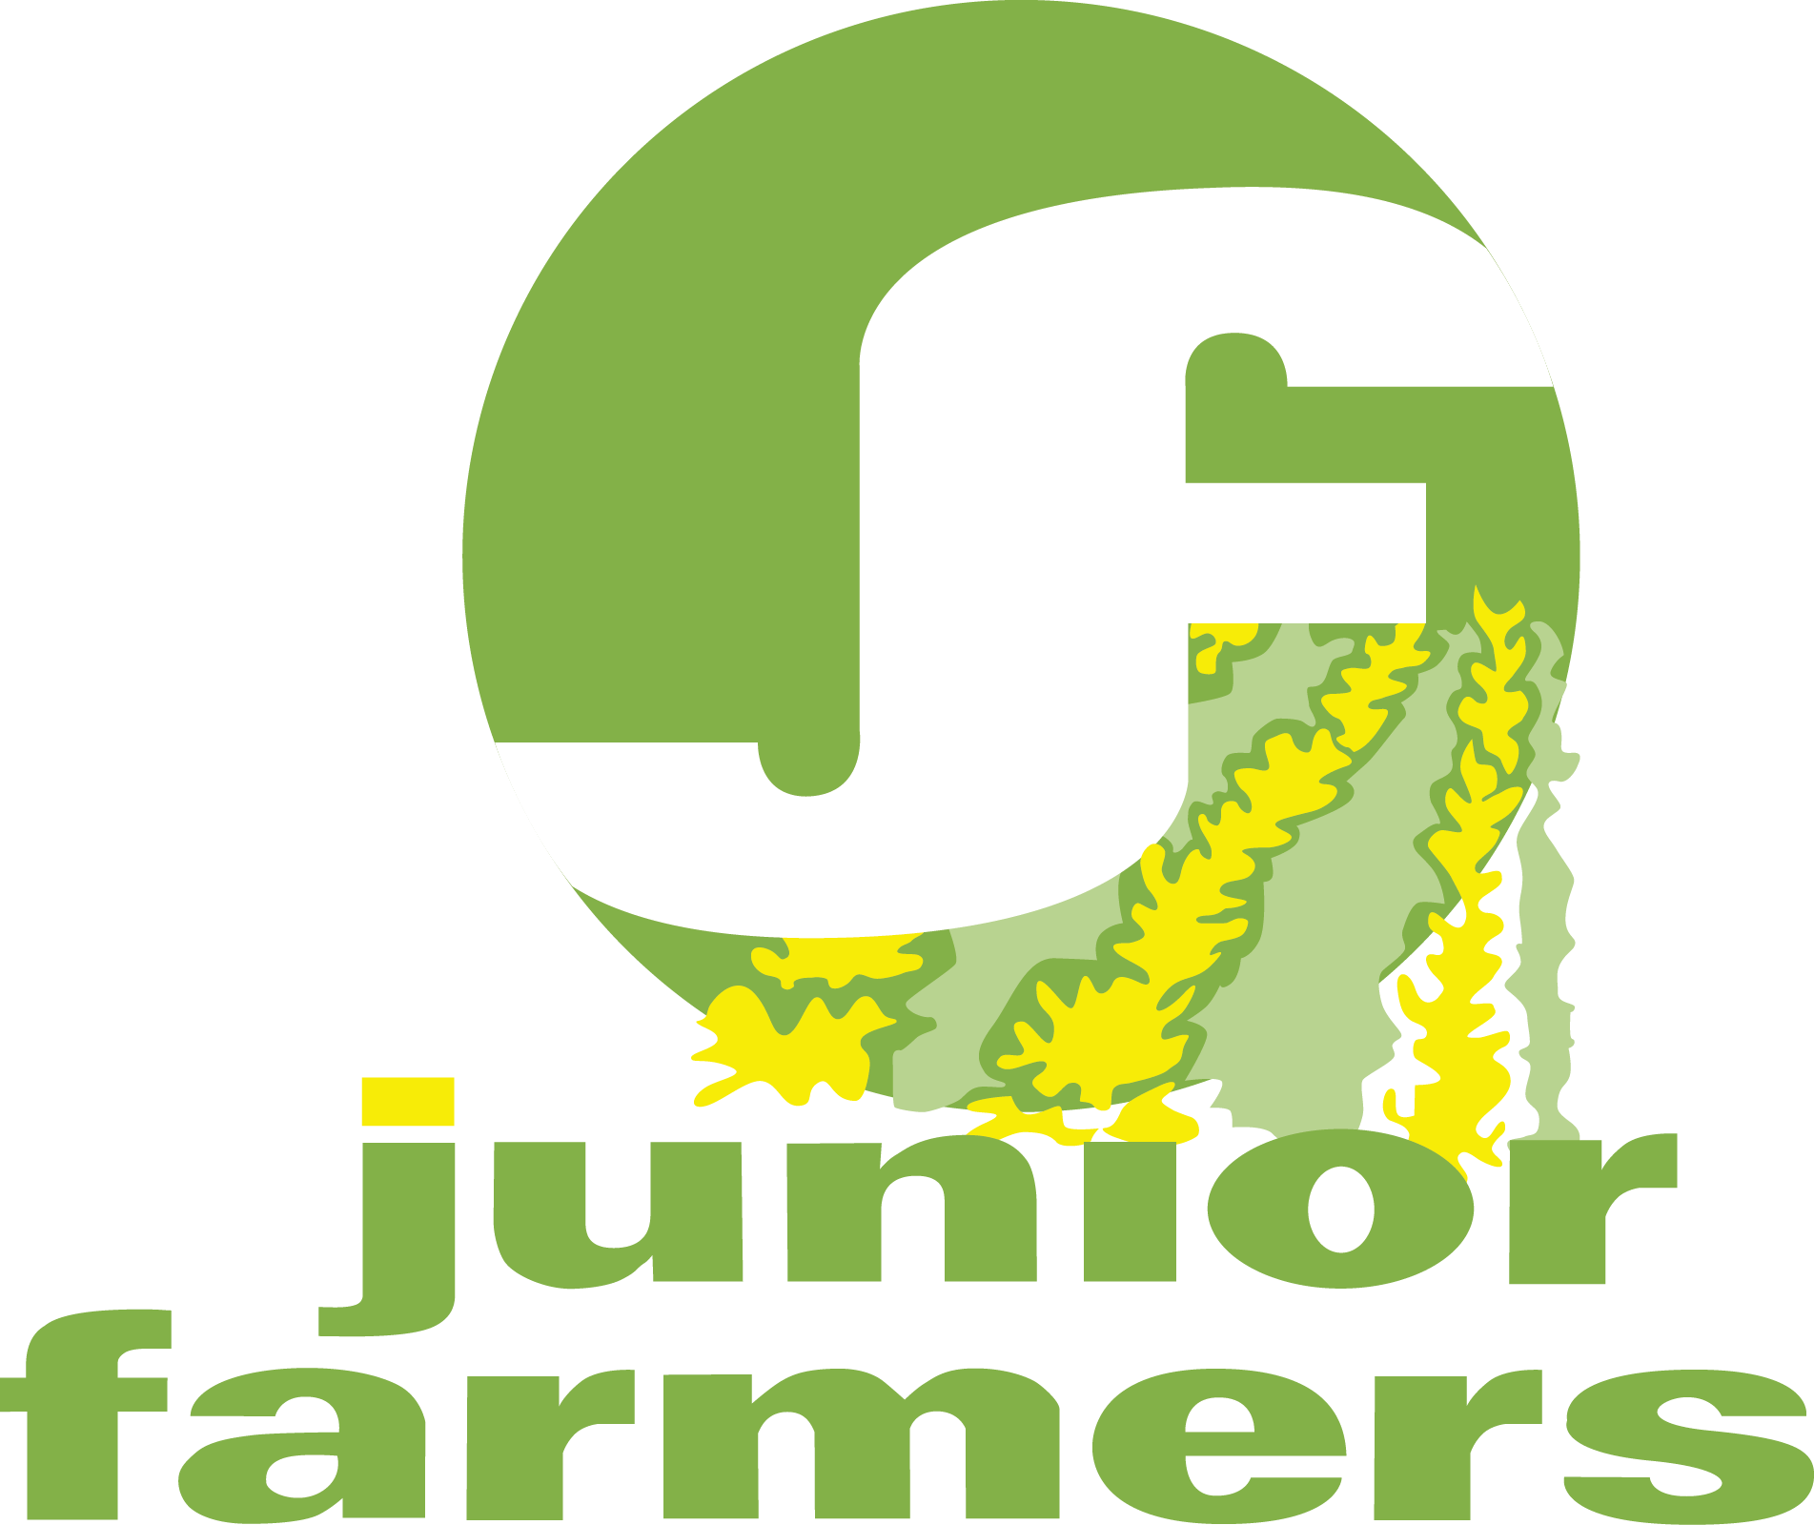 JFAO
CLUB AFFILIATION REPORT
2020

Club:
Year-end Membership:
Year-end New Members:
Club President:
Address:

Club of the Year Entry: ☐Yes ☐No
Agricultural Club of the Year Entry: ☐Yes ☐No

“to build rural leaders through personal growth, travel, experiences, and community betterment”

Date Received: | Time Received: | Received by:

Deadline for submission – 12 noon – January 2021 Board Meeting

Club Affiliation Checklist
Please ensure each of the following required sections is completed before handing in your affiliation forms. Incomplete forms will be returned with a late fee invoice.

☐ Minimum 5 family-friendly photos throughout the report and electronic copies email to pastpresident@jfao.on.ca – labelled with full names and activity shown.
☐ Section 1 – Club Photo(s) labelled with members’ full names and positions for archiving
☐ Section 2A – Provincial and Inter-club Participation Summary
☐ Section 2B – Club Projects and Events Participation Summary
☐ Section 3-4 – Community Betterment Project OR Joint JF and Youth Event OR Agricultural Education Project OR Conservation Project OR Social Engagement Project
☐ Section 5 – Club Charity and Volunteer Summary
☐ Section 6 – Media Coverage Summary
☐ Section 7 – Presentation of the Purpose and Structure of JFAO
☐ Section 8 – Presentation on Effective Meeting Procedures
☐ Section 9 – Club Meeting Summary and Official Minutes from two Club Meetings
☐ Section 10 – Club of the Year and Agricultural Club of the Year – Additional details on community betterment, agricultural awareness, joint JF and youth activities and events, optional historical JF item or info from your county for archiving etc. should be included here. Including reports with more details on other major projects and activities is strongly encourages, regardless of whether you are applying for club of the year.

Remember
JF mission is
“to build rural leaders through personal growth, travel, experiences, and community betterment.”
JF motto is
“Building Leaders. Building Communities.”
JF vision is
“for rural youth to connect, build and develop leaders for strong communities.”

These reports will be retained by JFAO until the April Board of Directors meeting
to create a summary of all provincial JF activities.

Make sure you store your affiliations reports in a safe place for future members to see!

Section 1: Club Photo
Provide club photo(s) with members’ names and executive positions labelled, and executive members listed. Headshots (in a member directory style or otherwise) may be used if a group photo is not available.

Section 2A: Provincial and Inter-Club Participation Summary

PROVINCIAL ACTIVITIES | NUMBER OF MEMBERS
Winter Games (Oxford)
Annual General Meeting (Zoom teleconference)
PD/Club Executive Training Session (Zoom teleconference)
Ambassador’s Banquet
Autumn Profile
Sing Swing
Ontario Young Farmer’s Forum
Provincial Workshop(s)
PROVINCIAL ACTIVITIES | NUMBER OF MEMBERS
JFAO Executive
Provincial Committee Chair
Provincial Committee Member
Provincial Organization Representative (OFA, Social Media, 4-H)
Representing JFAO at an Event
OTHER PROVINCIAL/INTER-CLUB EVENTS | NUMBER OF MEMBERS

Section 2B: Club Projects and Events Participation Summary
Please list all club and community projects and social events. This can include virtual events such as Houseparty, online trivia, and watch parties.
CLUB/COMMUNITY PROJECT | DATE AND LOCATION | NUMBER OF MEMBERS | NUMBER OF GUESTS
SOCIAL EVENT | DATE AND LOCATION | NUMBER OF MEMBERS | NUMBER OF GUESTS

Section 3-4: Community Betterment Project OR Joint JF and Youth Event OR Agricultural Education Project OR Conservation Project OR Social Engagement Project
Submit one to three of the following projects (print or copy additional pages as required). Additional projects can be further outlined in Section 10.
A Joint JF and Youth Event includes non-JF members under 25. A Social Engagement Project creates a way of engaging people in your club or community, possibly using an online platform, and could include online trivia events, watch parties, or online 4-H meetings.

☐ Agricultural Education Project ☐ Joint JF and Youth Event ☐ Conservation Project
☐ Community Betterment Project ☐ Social Engagement Project

PROJECT GOAL:
SPECIFIC ACTIVITY:
DATE: LOCATION:
NUMBER OF MEMBERS ATTENDING:
NUMBER OF NON-MEMBERS ATTENDING:
DID YOU PARTNER WITH ANYONE ELSE? ☐ YES ☐ NO WHO?
HAS YOUR CLUB DONE THIS PROJECT BEFORE? ☐ YES ☐ NO HOW MANY YEARS?
MEDIA COVERAGE? ☐ YES ☐ NO IF NO, WHY NOT?

Explain how the project came about, what was involved, and the reaction of members and the public.

Would your club do this project again and why? Is there anything you would change?

Section 5: Club Charity and Volunteer Summary
Please list all donations for the year. Print or copy additional pages as needed.
DATE | CHARITY OR COMMUNITY GROUP | RELATED FUNDRAISING ACTIVITIES | AMOUNT DONATED
Total:

Please list all additional volunteer time for the year. This can be done individually or as a group, and could include sewing masks or volunteering at a food bank.
Approximate hours = number of members x hours worked.
DATE | CHARITY OR COMMUNITY GROUP | VOLUNTEER ACTIVITY | NUMBER OF MEMBERS | APPROXIMATE HOURS
Total:

Section 6: Media Coverage
Please list all media coverage and include copies or recordings where possible (at least one must be included). Media coverage includes social media, and should include articles sent to or written by local media. Print or copy additional pages are needed.
Send all media releases or copies of printed articles to patrick@jfao.on.ca for inclusion on the JFAO website. In the event you have no media coverage, provide a copy of media releases and explain how you tried to obtain it and where.
DATE | MEDIA OUTLET | ACTIVITY OR PROJECT COVERED | HOW WAS YOUR CLUB SUCCESSFUL IN GETTING MEDIA ATTENTION? | WAS AN ARTICLE OR PHOTO PUBLISHED? | COPY INCLUDED? (Yes/No)

Section 7: Presentation on Purpose and Structure of JFAO
This may be completed as part of a regular meeting or a special event or on a virtual meeting platform. March or April may be a good time to help members understand what happens at the provincial level.

PROJECT GOAL: To increase members’ understanding of what our motto “Building Leaders. Building Communities” means and why we exist, including what we are seeking to accomplish as successful clubs, how JFAO’s success is dependent on member involvement, and how members, clubs, and JFAO fit together to build future rural leaders.

DATE: LOCATION:
NUMBER OF MEMBERS ATTENDING:
NUMBER OF MEMBERS ATTENDING FOR THE FIRST TIME:
PERSON MAKING PRESENTATION:
LENGTH OF PRESENTATION:

Explain how the presentation was made and how club members participated. Attach samples of any materials developed for the presentation or distributed if applicable.

Were there any questions about JFAO or suggestions from members on how JFAO is run or to improve JFAO?

How could you use the knowledge gained to help recruit new members and increase involvement?

Section 8: Presentation on Effective Meeting Procedures
This may be completed as part of a regular meeting or a special event, or on a virtual meeting platform. November, December, or January may be a good time to help your club’s annual general meeting run smoothly.

PROJECT GOAL: To increase members’ understanding of how to organize and participate in successful meetings and projects.

DATE: LOCATION:
NUMBER OF MEMBERS ATTENDING:
NUMBER OF MEMBERS ATTENDING FOR THE FIRST TIME:
PERSON MAKING PRESENTATION:
LENGTH OF PRESENTATION:

Explain how the presentation was made and how club members participated. Attach samples of any materials developed for the presentation or distributed if applicable.

Did members see any obvious ways to improve club meetings or meetings in other organizations they are in?

Section 9: Club Meeting Summaries
Please record meetings and connected social activities. How do you make your meetings interesting and fun? Print/copy additional pages as necessary. Attach official signed copies of minutes from two meetings.
DATE AND LOCATION (OR VIRTUAL MEETING) | NUMBER OF MEMBERS | NUMBER OF GUESTS | BRIEFLY DESCRIBE MEETING FOCUSES/HIGHLIGHTS AND PRE- AND POST-MEETING ACTIVITIES. INCLUDE AN INDICATION OF HOW YOU MAKE YOUR MEETINGS FUN AND INTERESTING

Section 10: Club of the Year and Agricultural Club of the Year Competition
Show us what your club is made of! Include more information and photos about other community betterment, agricultural education, conservation, and joint JF/youth projects, special club activities, fun events, recruitment projects, fundraising activities, media coverage, alumni items, or anything else that shows your club is the best! Use copies of forms from other sections or be creative! Please provide as much detail about events and projects as possible, and include photos, newspaper clippings or member testimonials. INCOMPLETE REPORTS WILL BE DISQUALIFIED.

INCLUDE THIS SHEET WITH YOUR REPORT

The JF Club of the Year will be scored as follows:
Club photo(s) labelled with members’ names and executive positions 5 _____
Leadership opportunities 15 _____
Range of opportunities available to members 10 _____
Membership participation – locally and provincially 20 _____
Community betterment, ag education, JF-youth activity, conservation project, or
Social engagement project (one to three projects, up to 10 points per project) 30 _____
Media coverage 10 _____
Structure and purpose of JFAO and effective meeting procedures 10 _____
Creativity of meeting and event ideas 15 _____
Quality of included Alumni item (newsletter, photo, news release) to be archived 5 _____
Support of the JFAO mission 10 _____
Quality of photos of events and activities – labelled 10 _____
Overall presentation, neatness, content, and description 10 _____
Total 150 _____

The judging criteria for Agricultural Club of the Year focuses on:
Originality of agricultural awareness activities 25 _____
Quality of activities 25 _____
Club participation 10 _____
Quantity of agricultural awareness activities 15 _____
Impact on the community 25 _____
Total 100 _____

Judge’s comments and suggestions: _____________________________________________________
___________________________________________________________________________________
___________________________________________________________________________________
___________________________________________________________________________________

