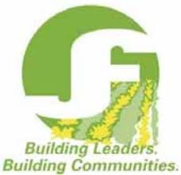
Professional Director RL Level 1

Survey

Do you hold an executive position in your club or a position on the provincial board? If you do, what is your position?

What were you hoping to get out of the program and did you get it?

What surprised you in the program?

What are the three most valuable topics you take from the course?

How do you see the knowledge gained being applied in your JF career and beyond?

Are there any ways you could see the course being improved?

Do you plan on continuing on with additional levels in the Professional Director RL program?

